**Unit 2. Communication Skills**

**The 7 c’s of communication:**

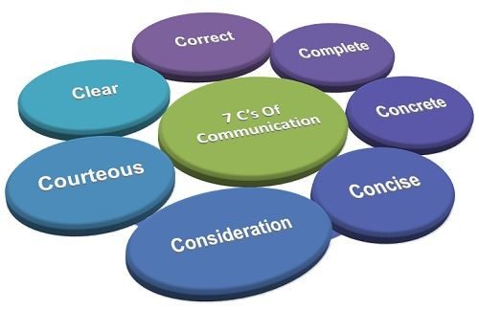

**Active listening involves**

* paying close attention to what the other person is saying,
* Building trust and establishing rapport
* Using nonverbal cues that show understanding such as nodding, eye contact, and leaning forward
* asking and clarifying questions
* rephrasing what the person says to ensure understanding ("So, what you're saying is…").
* focusing on the speaker, avoiding distractions like cell phones, laptops or other projects
* making comments or ideas to thoughtfully respond

Through active listening, you can better understand what the other person is trying to say, and can respond appropriately.

**Additional Points: 1) Start reading newspapers like economic times**

**2) Listen to English news like BBC news**

**3) Try to speak on the topic in front of mirror**

**How to improve verbal communication skills**

* **Think before you speak**-Taking time to reflect allows you to organize your thoughts into a concise, clear statement. If you feel rushed to answer, that feeling will get reflected in how you respond, so your message may not come out as intended
* **Use concise language**-Being succinct when speaking not only make your message easier to understand but also gets your main points across to the audience sooner.
* **Understand your audience**-ask yourself what your audience wants and needs to know and what their knowledge base is. When you understand who you are speaking to, it makes it easier to tailor your message to their needs
* **Be mindful of your tone**-Combing a friendly and warm tone with a smile makes a positive impression. For example, during a conversation, speak softly when they speak softly or if they have excited energy, try to match it.
* **Pay attention to your body language**-open body language also makes you appear more willing to receive messages, which makes others feel more comfortable speaking to you. You can also use gestures or facial expressions to emphasize points and grab audiences' attention or focus. However, be careful not to use too many gestures or appear overly animated, as this may become distracting.
* **Employ active listening**

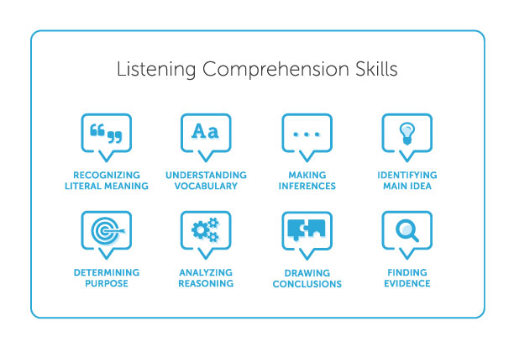

* **Speak with confidence**
* **Show your authentic self**
* **Practice your skills**
* **Gain feedback-**The insights of others will instruct you on what you already do well and where you need improvement.

**Tips to handle a webinar or stage**

* Know your attendees
* Show your Passion and Connect with your Audience
* Think about visual branding-Attention grabbing title
* Start Strongly-The beginning of your presentation is crucial. You need to grab your audience’s attention and hold it.
* Always focus on the right content.- Keep it Simple: Concentrate on your Core Message
* Remember the 10-20-30 Rule for Slideshows-

Contain no more than 10 slides;

Last no more than 20 minutes; and

Use a font size of no less than 30 points.

* Smile and Make Eye Contact with your Audience
* Tell Stories-Human beings are programmed to respond to stories
* Use your Voice Effectively
* Use your body too